Part 1: Data exploration and visualization
Variables and grouping choices
status: chosen as it had the highest Info Value (IV = 0.559), making it the most powerful predictor. It was left with its original grouping ("no checking account”, “balance < 0 DM", "0–200 DM", "≥ 200 DM / salary") to preserve as much information as possible.
duration: selected as our quantitative feature due to its strong predictive power (IV = 0.242). It was partitioned into 3 repayment bands—'< 12 months', '13–24 months' and '> 24 months’, helping capture non-linear trends.
The grouping works since grouping it via duration helped separate 2 high-risk tiers from the 2 less risky tiers, while keeping decent sample sizes (only one grouping going below 20). Not splitting status also helps us track the difference between having a low balance in their checking account and not having one at all.

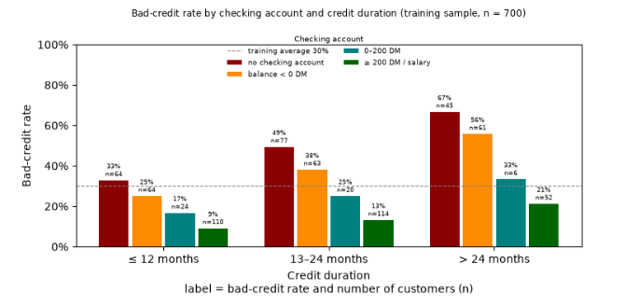

- Highest Rate vs. Most Bads: The highest bad-credit rate is observed among applicants with no account borrowing for > 24 months, reaching 67.4% ($n=45$) and the largest volume of bad credits is in the same checking category with a medium duration of 13–24 months, accounting for 38 bad credits out of the 210 defaults in the training sample. ($49\%$ rate)
- Checking Status: Checking status acts as a powerful divider with applicants with stable balances showing default rates below the $30\%$ average across all duration windows (only variation when n is too small).
- Reliability: interaction pattern is robust. Almost every group maintains a solid sample size ($n≥20$), ensuring observed trends across duration lengths are dependable rather than artifacts of small sample variance. Additionally, with other duration groupings, the trends are mostly aligned, and status remains a strong predictor with further defined groups not adding a lot of new detail, prompting to keep this.
- Takeaway: Long-term loans ($>24$ months) extended to applicants with overdrawn accounts or no fiscal information carry high default exposure. The bank should tighten underwriting thresholds, mandate lower loan amounts, or require co-signers for this high-risk segment.

Part 2: WOE and logistic regression
Predictor selection and level choices
- status ($IV=0.539$): selected as the top predictor and preserved original categories ("no checking account”, “balance < 0 DM", "0–200 DM", "≥ 200 DM / salary")
- savings ($IV=0.300$): partitioned into original categories (unknown, < 100 DM, 100–500 DM, 500–1,000 DM, ≥ 1,000 DM). Higher savings map directly to higher WoE values (greater safety).
- duration ($IV=0.242$): quantitative feature partitioned into bands (≤ 12 months, 13–24 months, > 24 months) maintaining risk scaling and sufficient sample sizes.
- purpose ($IV=0.227$): sparse and similar categories merged into 4 risk tiers for stability ('new car', 'furniture/equipment', 'vacation' were merged into a low risk group as people spending on these tend to have stable cash flows as these are discretionary spending and not essentials).
- credit_history ($IV=0.200$): low-risk levels (all credits here repaid', 'existing credits paid duly') combined resulting in 3 tiers.
Justification: $k=5$ predictors were selected based on 5-fold cross-validation, capturing maximum predictive power (AUC = 0.766) while maintaining parsimony and preventing overfitting.

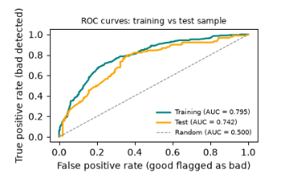

- Highest IV & WoE Meaning: status has the highest IV, indicating account liquidity is the strongest default discriminator. WoE values range monotonically from positive values for safe balances ($≥200\text{ DM}$) to negative values for overdrawn accounts and no fiscal history ($\text{balance }<0\text{ DM}\text{ and no account}$), where negative WoE denotes heightened default risk ($\ln\left(\text{Good}/\text{Bad}\right)$).
- Discrimination & Overfitting: The model achieves a training AUC of 0.795 and a test AUC of 0.742. The modest gap mirrors 5-fold CV score, showing decent generalization and no evidence of overfitting.
- Business Conclusion: we effectively segment portfolio risk, isolating the riskiest $30\%$ of test applicants to capture a $51\%$ bad rate compared to just $21\%$ in the remaining $70\%$.
- Model Limitation: The model relies entirely on static financial snapshots (status and savings) without incorporating real-time income flows or macroeconomic indicators, creating exposure to score drift during economic downturns.
Part 3: Scorecard
predictor | level | points
status | 0–200 DM | 111
status | balance < 0 DM | 93
status | no checking account | 86
status | ≥ 200 DM / salary | 125
savings | 100–500 DM | 125
savings | 500–1,000 DM | 140
savings | < 100 DM | 100
savings | unknown / none | 93
savings | ≥ 1,000 DM | 127
duration | ≤ 12 months | 119
duration | 13–24 months | 102
duration | > 24 months | 81
purpose | Risk Tier 1 | 118
purpose | Risk Tier 2 | 96
purpose | Risk Tier 3 | 90
purpose | Risk Tier 4 | 87
credit history | Risk Tier 1 | 114
credit history | Risk Tier 2 | 99
credit history | Risk Tier 3 | 79
credit history | Risk Tier 4 | 74



